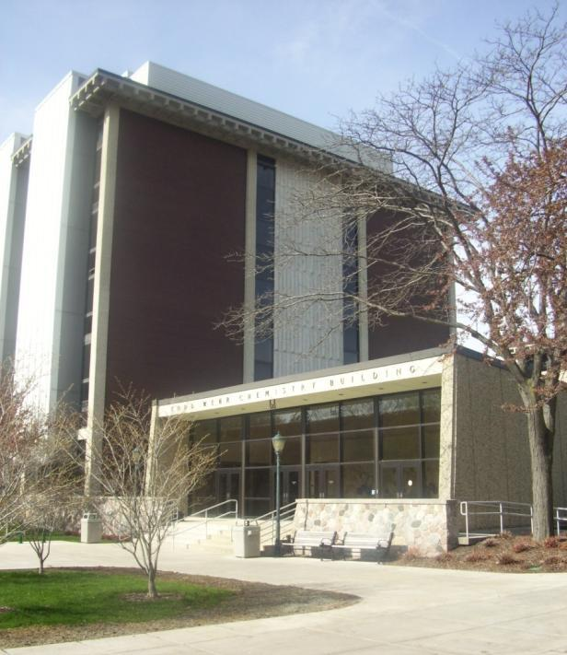
Todd Wehr Chemistry

The Todd Wehr Chemistry building opened in 1966 and has supported the training of thousands of scientists, science teachers, engineers, and health care professionals. The building is also home to thriving faculty research programs, which engage graduate, undergraduate and postdoctoral research associates in exploration of cutting-edge research in a wide range of chemistry-related disciplines.

Accessibility

Entrances
East Entrance – accessible with ramp and automatic door

(East view, arrow points north)

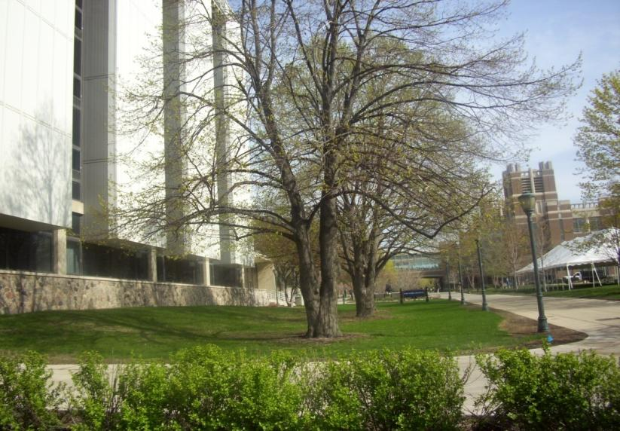
Women’s Bathrooms
Room 005
Room 120
Room 234
Room 301
(4th floor closed for construction)
Room 501
Room 660

Men’s Bathrooms
Room 006
Room 118
Room 235
(4th floor closed for construction)
Room 525
Room 660

Elevator Location
Through hallway doors, across room 105
(North view)

Wehr Chemistry Building
P.O. Box 1881
535 N. 14th St.
Milwaukee, WI 53201-1881
(414) 288-3515 | (414) 288-7066 (FAX)

