Weasler Auditorium

The Weasler Auditorium is connected to the AMU via a covered walkway. The Weasler is a two level auditorium that hosts a variety of talks and performances throughout the semester.

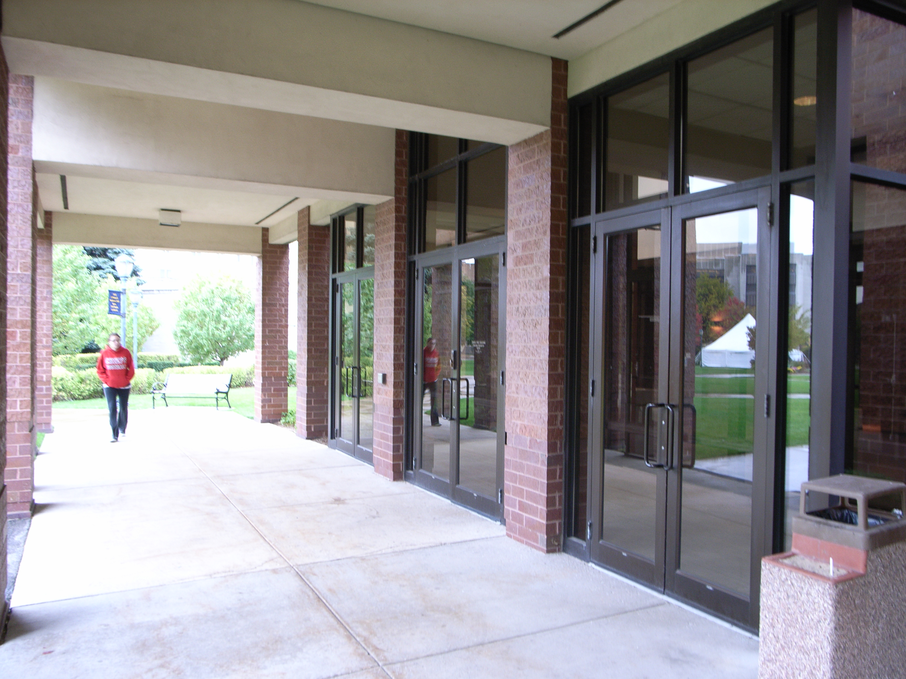

(Arrow points North)

Accessibility

Entrance
Wheel Chair Accessible, Automatic doors
(Pictured)

Women’s Bathrooms
Room 114

Men’s Bathrooms
Room 108

