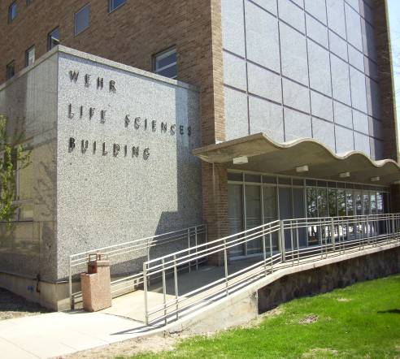
Wehr Life Sciences

Houses Biological Sciences.

Accessibility

Entrances
East Entrance – automatic door, elevator through double doors
West Entrance – ramp

Women’s Bathrooms
Through East doors, through second set of doors, down right hallway
Across Room 203

Men’s Bathrooms
Across Room 111
Across Room 510
(West view, arrow points north)
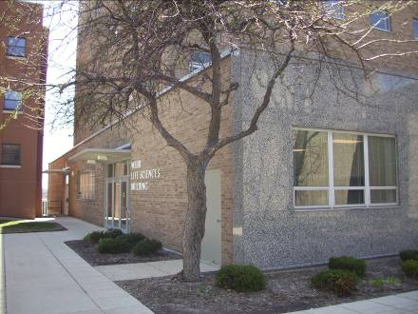

(East view)

Wehr Life Sciences
Marquette University
Dept of Biological Sciences
P.O. Box 1881
Milwaukee, WI 53201-1881
(414)288.7355| (414)288.7357 (FAX)

