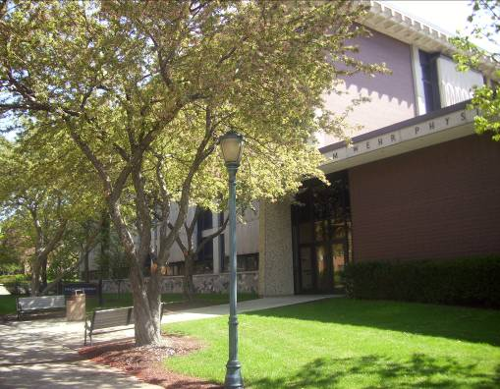
Wehr Physics

Houses the Physics Department.

Accessibility

Entrances
West Entrance – automatic door

(West view, arrow points north)

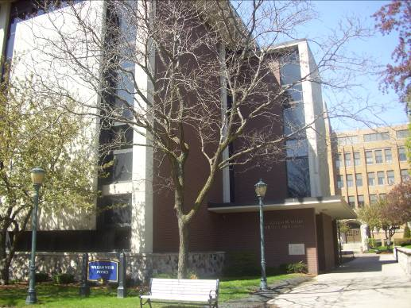

Women’s Bathrooms
Room 020
Room 234
Room 338
Room 433

Men’s Bathrooms
Room 021
Room 137
Room 235
Room 363
Room 441

Elevator Location
Across Room 134

(Northeast view)

Marquette University
Physics Department
Wehr Physics
540 North 15th Street
Milwaukee, WI 53233
(414) 288-7247 | FAX (414) 288-3989

