THE STUDENTS OF THE DEPARTMENT OF
COUNSELOR EDUCATION AND COUNSELING PSYCHOLOGY
AT MARQUETTE UNIVERSITY
CORDIALLY INVITE YOU TO THE
19th Annual Diversity Gala

SATURDAY, THE FOURTH OF MAY
TWO THOUSAND AND NINETEEN
SEVEN O’CLOCK IN THE EVENING

MARQUETTE UNIVERSITY
ALUMNI MEMORIAL UNION BALLROOM
1442 W. WISCONSIN AVENUE
MILWAUKEE, WI

INDIVIDUAL RESERVATIONS:
$20 GSO MEMBERS AND THEIR GUESTS | $30 NON-GSO MEMBERS AND THEIR GUESTS
Tickets will be available at the door at a $5 increase.
KEYNOTE ADDRESS GIVEN BY: TBD

HEAVY HORS D’OEUVRES AND CASH BAR
SCHOLARSHIP PRESENTATION
SILENT AUCTION TO BE HELD
FORMAL DRESS

PLEASE RSVP BY APRIL 15TH VIA LINK:
TBD

CECP GSO SOCIAL CHAIRS:
KRYSTAL.BUCHANAN@MARQUETTE.EDU OR KRISTEN.ROSLAND@MARQUETTE.EDU
MU CECP OFFICE 414-288-5730
~ CREDIT, CASH OR CHECK PAYABLE TO MU CECP ~

MS. THELMA SIAS
FORMER WE ENERGIES EXECUTIVE AND A LONGTIME MILWAUKEE COUNTY
FIXTURE WHO WORKED WITH CHILDREN’S HOSPITAL FOUNDATION
AND UNITED WAY OF GREATER MILWAUKEE

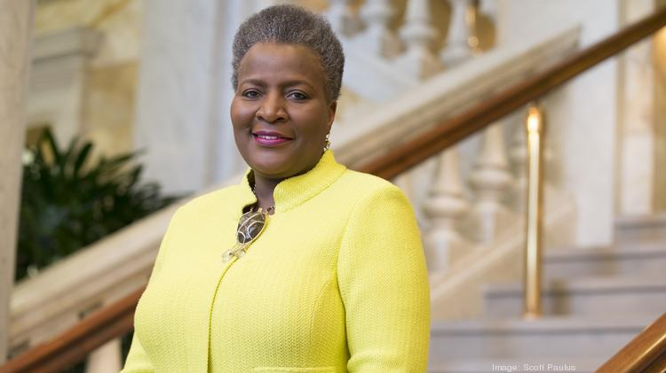

Thelma A. Sias retired very recently, after a long and storied career as both a prominent business woman, and one of the most influential executives in Milwaukee. Her career as an executive at We Energies has been recognized by countless local organizations, including being declared one of the Milwaukee Journal Sentinel’s “Top 40 Under 40” local professionals in 1992, and eventually being inducted into the “Top 40 Under 40” Hall of Fame in 2015. Additionally, Ms. Sias has been recognized by the Milwaukee Common Council for her many contributions to the local community, and most recently, the Milwaukee Urban League established the Thelma A. Sias Fellows of Distinction award, in order to ensure her legacy continues. In her personal life, she has served on boards for numerous local organizations, including both the Children’s Hospital Foundation, and a past co-chair for the United Way of Greater Milwaukee’s capital campaign. Thanks in part to Thema Sias’ efforts, Milwaukee is a better place to live and work.

