The Engaged Scholar Virtual Book Read Discussion
Co-led by the Office of the Faculty Affairs, Diederich College of Communication, and Office of Economic Engagement
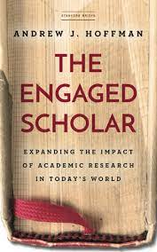
In a recent interview about his new book, The Engaged Scholar, University of Michigan Center for Positive Organizations faculty associate Andrew J. Hoffman argues that, “academic research is becoming increasingly irrelevant as the work becomes too insular, the language too opaque, the journals too inaccessible, the cultural norms of disciplinary boundaries too balkanized [--] the reward systems cement these problems in place.” His recommendation is that we break out of our siloed research communities and bring our work to a world that needs it.

Join Gary Meyer, senior vice provost for Faculty Affairs (Office of Faculty Affairs), Kati Berg, associate dean of Graduate Studies and Research (Diederich College of Communication), and Dan Bergen, executive director of Community Engagement (Office of Economic Engagement), for a book read and discussion regarding this recently published book, and the opportunity to consider the relationship between faculty research, rewards and incentives structures, and the mission of our institution.

Discussion will take place during the summer in two 75-minute sessions. The size of the group or groups will be determined based upon interest. These sessions will focus on engaged scholarship, including opportunities and challenges given Marquette’s mission and current promotion and tenure criteria.

Faculty interested in participating in this book discussion should send an e-mail noting interest and general availability to Gary Meyer (gary.meyer@marquette.edu) on or before Friday, May 21, 2021. Books will be provided at no cost to participants.

