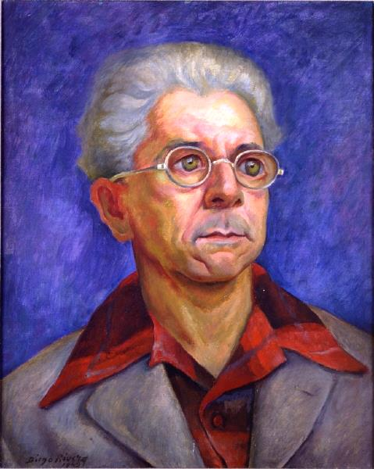
What is Hispanic?
August 19-December 20, 2015
What is Hispanic? presents a selection of artwork from the Haggerty’s permanent collection that investigates this question. The exhibition will showcase Medieval to contemporary paintings, prints, and photographs by Hispanic artists that address themes such as: politics, sexuality, history, family, migration, social justice, war, peace, race, sexism, spirituality, and hatred. The pieces will reveal personal stories about the featured artists that inspire dialogue on the Hispanic experience and identity, as well as discussions on Surrealism, Cubism, the avant-garde, and Expressionism.
Works by Pablo Picasso, Salvador Dalí, Juan Correa de Vivar, Carlos Alfonzo, Tom Wudl, Carlos Hermosilla Álvarez, Roberto Matta, Enrique Chagoya, Joan Miró, Antoni Tàpies, Diego Rivera, and others are included in the exhibition.
What is Hispanic? was curated by Dr. Scott Dale, associate professor, Department of Foreign Languages and Literature, Marquette University.

Diego Rivera, Mexican, 1886 - 1957
Portrait of Scharmel Iris, 1943
Oil on canvas
21 x 16 3/4 in
53.34 x 42.54 cm
91.7
Gift of Leonard and Evelyn Lick in Memory of Anita and Anthony Vincenzo
Collection of the Haggerty Museum of Art, Marquette University

