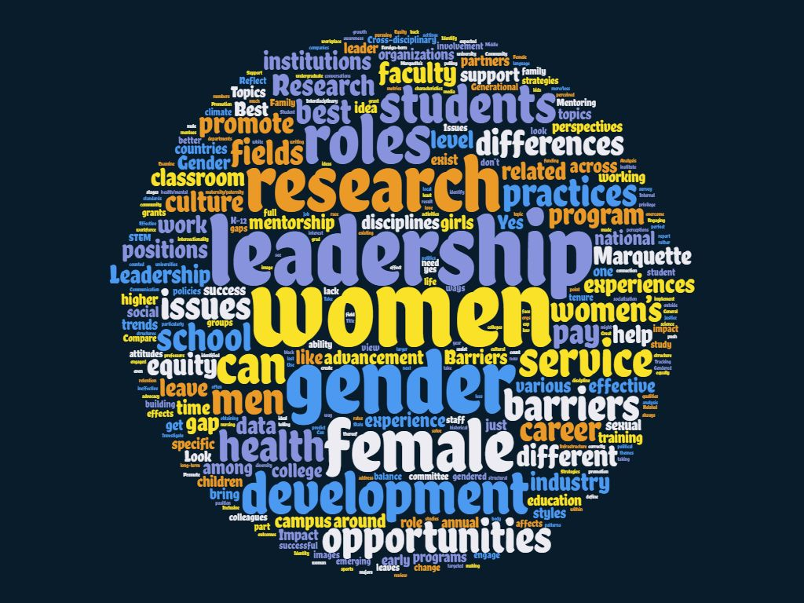
Institute for Women’s Leadership – Planning Discussions Feedback Summary

February 18 & 28, 2019
Research Topic Themes:
- Session 1
- Pay gaps
- Tenure and retention for female faculty
- Systemic barriers
- Comparing Marquette’s female leadership to other institutions
  - Best practices
- Preparing students for leadership (K-12 through college)
- Mentorship
- Structural change
- Interdisciplinary approaches to female research
- Female entrepreneurship
- Maternity/family leave concerns
- Profile successful female leaders
- Intersectional female leadership
  - Look at women who are also racial, sexual, religious minorities
- Annual reports of current climate/progress on women in leadership
- Characteristics of female leaders
  - Differences from male leaders
- Comparison of women’s experience on Marquette campus compared to men’s
- Perception of women in leadership

- Session 2
- Male allyship
- Discrepancies/inequities in higher ed and beyond
- Intersectional identities
  - Privilege
  - Advocacy/social justice
- Foreign-born women’s challenges
- Empowering female students
- Salary negotiation/pay gaps
- Women in STEM/Tech
- Work-life balance
  - Navigating life milestones
- Women’s health/mental health/body image
- Female leadership disparities among fields/disciplines/areas
- Climate assessment at MU
- Leadership styles
- Defining leadership
  - What makes one a leader?
  - Dependent on position?
- Experience of young girls/students
  - When do leadership inspiration/barriers start?
- Mentorship
- Cultural barriers
  - Sexism
  - Expectations
  - Gender roles
  - Microaggressions
- Effective female leadership characteristics
- Female leadership at MU vs other institutions vs national level

Ways to engage faculty, students, etc. in research Themes:
- Session 1:
- Grants/funding for research
  - Students
  - Faculty
- Research mentoring
- Partnerships with local organizations
- Systemic change
  - P&T
- Promote student research
  - Symposiums
  - Space for students to share ideas
  - Classes/internships focused on research
- Encourage cross-disciplinary research
- Allow faculty more time for research
- Promotion of current ongoing research/past research/alumni research
- Involve community partners/alumni in research

- Session 2:
- Unlearning sexism
- Book clubs
- Mentoring
- Bring female speakers to campus
- Opportunities to present research
- Help with grant-writing and funding
- Interdisciplinary collaboration
  - Networking opportunities
  - Involve students and staff
  - Informal events
  - Physical space to meet and collaborate
- Collaboration with local corporations, businesses, nonprofits, high schools, etc
- Focus groups
- Portal or system that allows people to find ongoing research opportunities
- Research groups/cohorts
- Research-focused seminars or workshops
- Publicize/promote MU research to make it visible to campus/MKE community

Partnership Opportunities Themes:
- Session 1:
- Interdisciplinary partnerships at MU
  - Different departments
  - Academia + administration
  - Involve students
  - Internal mentoring
- Partner with leaders from local businesses
  - Mentoring for students in the same field
  - Internship/professional development opportunities
- Government and non-profits
- E-LEAD
- Office of Diversity & Inclusion
- Other local institutions
  - Alverno
  - Mt. Mary
  - Tech schools
- Student organizations

- Session 2:
- Partner with already existing organizations on campus
  - WIN and FELOS
  - Student orgs
- Local nonprofits
- Networking opportunities w/in community
- Local corporations/businesses
- Conferences and seminars (internal and external)
- Internship opportunities for students
  - Fellowships for faculty/staff
- Women’s orgs in MKE or other local institutions
- Interdisciplinary collaboration
- Training opportunities
  - Unlearning sexism
  - Leadership certification
- Alumni

Leadership Development & Networking Themes:
- Session 1:
- Engage both women and men
  - Share perspectives
  - Train men as allies
  - Advocacy
- Interdisciplinary research/partnerships
  - Support groups/cohorts
- More involvement with community
  - Events off-campus
  - Invite community to campus
  - Visit/shadow leaders in community/industry
- Professional development/training
  - Workshops
  - Skills training
  - Grant-writing
  - Student leadership training
- Publicize/showcase female-led research, on campus and off
  - Publish on website
  - Symposiums/poster sessions
  - TED event
  - Recognition events
- Networking
  - Events
  - Connect students with industry leaders
- Mentorship
  - Women supporting women
  - Senior faculty – new faculty
  - Grad students – undergrad
  - Faculty – students
  - Industry leaders – students
  - Marquette students – high school students
- Bring female speakers to campus
  - Success stories
  - Panel discussions
- Diversity and inclusion
  - Women of color

- Session 2:
- Mentoring
  - Mentors from both off and on campus
  - Faculty and students
- Fellowships/internships/shadowing w/ leaders on/off campus
- Events in community
  - Leave campus
  - Invite community to campus for events
- Athletic partnerships
  - AHPRC
- Informal networking events/groups
- TED talks
- Create a pathways/pipeline program for women on campus
- Incentivize leadership training
- Include discussion/training on leadership outside of higher-ed positions
  - Non-traditional careers/paths
  - Male-dominated fields
- Workshops/training
  - Leadership development
  - Bias training
    - Include men!
  - Negotiation
- Speaker series
- Programming/involvement with local younger women
  - K-12 students
  - Daycares
  - Girl Scouts
- Career planning
- Curriculum/learning communities for students

March 22 & 27, 2019
Partnerships & Diverse Audiences:
Session 1
Who:
- Who should the partners be?
  - Corporate, women’s associations, chambers of commerce, schools, other universities (especially with similar institutes)
- Who are your diverse audiences?
  - Marginalized groups and men as allies
What:
- What is the definition of success of a partnership?
  - An agreed upon and achieved ROI
- What is the time frame?
  - Depends upon level of partnership
    - Explore what’s out there already
- What are anticipated outcomes?
  - Expanding opportunities for women
    - Long term and short term
    - Developing structure for success
    - Increasing awareness and education
How:
- How will be define partnership?
  - Design, funding, participation
  - Levels of partnership
  - Mutual benefit for both institute and partners
  - Amongst schools/programs at Marquette
    - Internal vs external
- How can we manage partnerships and programming?
  - Staffing, faculty,
  - Review other department management structures
    - What do they look like?
Where:
- Where do you facilitate the programming?
  - Mix of on/off campus programming
  - Community centers
  - High school/middle school
  - Chambers of commerce
- Where can we seek funding to facilitate partnerships?
  - Corporate partners
  - Focus in Milwaukee first
    - Then look nationally
  - Women’s associations
  - Private foundations
  - Nonprofits
- Where in the programming do we engage the stakeholders from the partnerships?
  - Let partners have a voice at the table
  - Help design (funding/program)
Session 2
Who:
- Who’s doing this well?
  - Audit best practices locally & nationally
    - Also other Jesuit universities
- Who might partner?
  - Other Jesuit universities
  - Internally
    - EOP
    - Intercultural engagement
    - Center for Gender & Sexuality
    - Community Engagement
    - Student Orgs
    - Student Affairs
    - ELEAD
    - Diversity & Inclusion
    - Faculty w/ expertise
    - Provost
    - President’s office
    - University leadership & board of trustees
    - Center for Teaching & Learning
  - Externally
    - Other universities, locally
What:
- What’s our scope/purpose?
  - Research effective programming and audit what we already do
  - To transform Marquette into a national leader and model for gender justice
    - Implies intersectionality
Where:
- Where will research be completed?
- Where will we identify partnerships?
- Where do programs happen?
When:
- When does it make sense to partner?
  - From the beginning in order to have a sense of our own needs
    - Data informed
Why:
- Why should we partner?
  - To put action to research
  - To broaden impact
  - To add credibility and accountability
- Why diverse audiences?
  - To address equity issues on campus & beyond
  - To spark greater awareness of our collective knowledge
Transforming Marquette:
Session 1
Who:
- Who do we involve?
  - All listed: community, staff, faculty, students, leadership
- Who is identifying prioritization?
  - Those involved for diversity and inclusion
What:
- What does it mean to transform Marquette?
  - Stay relevant
- What are the problems we are trying to solve?
  - Faculty development
  - Important to growing
  - Reputation
  - Recruiting
- What are the risks of not transforming Marquette?
  - Marquette doesn’t have a good sense of what gender equity looks like
How:
- How do we make it attainable?
  - Benchmarking: identify where we need to go
- How will we know MU is transformed?
  - Look at retention data
    - Gender, gender/college, etc
- How do we convince stakeholders that Marquette needs to transform/keep them interested?
  - Ignatian colleges/Jesuit mission – include as able
  - Men and Women in service of others
- How do we get “buy in” from different departments?
  - Don’t always include the same people
- How do you find common goal/focus/objectives?
  - Story-telling vs metrics
Where:
- Where do we need to transform at Marquette?
  - There is a wealth of scholarship on this topic already?
- Where is our target audience?
  - Best practices research
  - Companies, other Jesuit universities
- Where are the populations that may in influenced by this (pipeline)?
  - There are places on campus already (engineering) that do this well
- Where do we look for strategies/models for where we want to be?
  - Use forums to highlight where this is done
When:
- When do we start?
  - Now and ongoing
- When will change happen (timeline)?
  - Start with progress made so far
Why:
- Why do we want/need to transform Marquette?
  - Retention and recruitment of ALL stakeholders
    - Faculty, staff, students, community
- Why should other people buy into this?
  - Women in leadership changes organizations
  - Women in leadership matters
  - Women in leadership makes us better
Session 2
Who:
- Who are the marginalized groups we need to include?
  - Black people at Marquette
  - First-generation students
  - Foreign born
  - LGBTQ
  - English second language
  - Born to foreigners
  - Class
  - Women in business/college
  - Traditional Male-dominated fields
- Who will be affected?
  - Future state of Marquette
  - Alumni
  - Current state
What:
- What do we mean by transforming?
  - Women in a variety of leadership roles around campus
  - Qualifying women in an intersectional way
  - Women in decision-making roles
  - Spaces for women to get together
  - Marquette seen as “leading the way”
  - Marquette would serve and shape larger Marquette community and the world
- What does success look like?
  - It’s important to make sure that transformations take hold
- What does this mean to students?
  - This could be different for them
  - Role of women from other cultures
  - Diversification of student population
How:
- How have other organizations done this and how successful?
  - Do we benchmark?
  - Milwaukee Women Inc
  - Tempo
  - Add sophisticated approach from Marquette Research capability
  - Far do we go when talking about gender?
Where:
- Where do we start?
- Where will research and transformation efforts take place?
- Where will the Institute be located?
- Where does transformation most need to happen?
- Where are our partners?
- Where do we want to influence/inspire change?
- Where is this documented?
When:
- When can we start?
- When to evaluate progress?
- When to execute each aspect of transformation?
- When to sunset or adjust?
- When to utilize outside resources/partners?
Why:
- Why hasn’t this happened before (previous roadblocks)?
  - Systems in society that prevent advancement
  - Me too movement
  - Social media changed perspective
  - How viewpoints get spread
  - $$$
  - Decision makers are men/leaders
  - Myths about women
  - Bias/unconscious
  - Transformation
  - Time as barrier
  - Celebrate success when it happens
Inclusion & Intersectionality:
Session 1
Who:
- Who is Marquette (Who is included)?
  - Catholic/Jesuit core, with welcoming diversity
    - Progressive
- Who are key populations to engage?
  - Women – students, faculty, staff, community, alumni
- Who are we trying to impact through research/programming?
  - Branching to nonprofit orgs, women roles & leadership in the city, corporations
What:
- What is the end goal?
  - No more need for such an initiative
- What is off limits?
  - Limits would depend on the goal
How:
- How do you engage diverse populations?
  - Invite key players to the table
  - Reach out to everyone with personalized invitations
- How do we avoid isolating men as allies?
  - Partnerships and fostering those relationships
- How will IWL impact Milwaukee?
  - Recognition in the public
Where:
- Where do you engage external audiences?
  - On campus and in the community
  - Reach out via social media
  - Women leaders and others already working towards a similar initiative
- Where does Marquette’s mission intersect with IWL?
  - Who’s already connected to Marquette
  - Re-engaging current audience
When:
- When do we engage students on campus?
  - Now!
- When will we know we succeeded?
  - Still have to establish measurement or goal
Why:
- Why does intersectionality matter?
  - Marquette should be a part of the national movement
- Why is this a research institute?
  - One purpose may be to research the role of women, but we have to find our focus in being a research institute
Session 2
Who:
- Who is included?
  - Staff is important to include
- Who are we serving?
  - Potential to serve on campus locally and globally
  - Serving the future
- Who is serving?
  - Donors serve the process
  - Passionate change-makers
- Who is buying in?
  - Top-down buy-in
    - Senior leaders
  - All must buy in
- Who has been marginalized?
  - Those not typically in the “room”
  - Need to welcome those marginalized
- Who has answers we can build on?
  - Cross-dept communication
  - Create a database!
    - Inclusion
    - Dan Bergen?
  - Large base empowered to contribute to solutions
  - Identify those currently doing related work
What:
- What does inclusion mean?
  - Inclusion = belonging, not just being invited
  - Inclusion = having a voice
- What is the difference between diversity and inclusion?
  - Inclusion is harder to measure
- What is the difference between equality and equity?
  - Equity recognizes different needs, creates access
  - Identify institutional parameters
  - Learn what research exists and build from there
How:
- How do we ensure all voices are heard?
  - Start with multiple modes of feedback
- How do we ensure that the margins are involved in planning and implementing?
  - Going where marginalized people are
- How can the institute contribute to making Marquette more equitable (from policy to programming)?
  - Inclusive teams, inclusive leadership
- How do we prevent the margins from being tokenized and overburdened?
  - Not just invite, also support and mentor diverse members
- How do we learn about peoples’ experience at Marquette?
  - Be flexible throughout process to learn from discoveries along the way
- How do we ensure institutional support?
  - Incentivize involvement and participation
- How do we keep it real?
  - Transparency and truthfulness
Where:
- Where is the sphere of influence for this institute going to be?
  - Make accessible to all
  - Multiple language/abilities/accessibility
When:
- When will we redo the climate study?
  - Now is a good time in history for this research
Why:
- Why is it important to be inclusive?
  - Mission-focused
  - Stronger community
  - Multiple viewpoints/experiences
  - Increased innovation
  - Results must matter
    - Remove stumbling blocks
    - Funding
    - Conversations with donors
    - Action plan for outcomes
- Why is the focus on intersectionality important?
  - Women and others are intersectional beings
  - Important to name marginalized populations within women and other groups
Mentoring:
Session 1
Who:
- Who are we mentoring?
  - Mentoring everyone!
  - Priorities: under served and at risk
  - Students and staff
  - Destigmatize asking for help or for a mentor
- Who’s going to evaluate program effectiveness?
  - Evaluation from multiple sources
  - Student, university
- Who will develop the program?
  - Creating a framework from the top but allowing the details to be filled in at the bottom
What:
- What makes an effective mentor?
  - Experience, empathy, willingness, time, training all go into being an effective mentor.
- What resources are needed and available?
- What is the content/structure?
  - Mentors/mentees at and for all parts of the university
    - Faculty need to be mentored
- What are the goals?
  - The goals of the program: future leaders, reduce waste of potential and resources
  - Dependent on relationship
- What are the obstacles?
How:
- How will it work?
  - Need to look to other universities and industry to answer the “how”
- How does someone get involved – access?
  - Mentees are chosen… new faculty, new position have to be mentees
- How are mentors trained?
  - Continuous education of mentorship training
Where:
- Where will this occur?
- Where do we find mentors and mentees?
When:
- When will meetings/training occur?
  - Must be careful not to burden mentors with too much
Why:
- Why is it important to Marquette and the strategic plan?
  - Waste of potential
- Why should people get involved?
  - Effective communication of potential to others
Session 2
Who:
- Who are the mentees?
  - Should be open to all (faculty, staff, students, visiting professors, community)
- Who defines the model?
  - Good mentors don’t all have to be internal
  - Find out where it’s working
What:
- What is the benefit to Marquette?
  - Retention
  - Break down silos
  - Help with recruitment
How:
- How do we know it’s successful?
  - Feedback from all parties to help determine success
  - Retention of participants at the university
Where:
- Where is it housed?
- Where do we find mentors/mentees?
- Where are we most needed?
- Where do our community partners fit in?
- Where does our reach extend?
- Where are the existing community programs?
- Where do good programs exist?
- Where do we find information about what not to do?
- Where does it fit into strategic plan?
- Where can participants get support and resources?
When:
- When do we ask for feedback?
  - Gather continuous feedback
Why:
- Why does it matter?
  - Can help propel careers according to data
  - Training provides consistent feedback
  - Can address varying needs of women
  - Role models can expand network
    - Especially in departments not well represented)
- Why focus on women?
  - Support for women/margins elevate all

April 12, 2019 – Chicago Circles
Themes:
- Major challenges for leaders (men and women) include:
  - Managing people/teams
  - Creating an inclusive/diverse culture
  - Recruiting/retaining the right people
  - Professional but transparent communication
- Differences for Male and Female leaders include:
  - Women seen as “aggressive” or “bossy” while men are seen as assertive
  - Men held less accountable than women for mistakes, failures, unprofessional behavior
  - Women must tread more carefully in communication issues
  - Women must work harder to be heard and taken seriously
  - Differences start with company culture
- Programs and projects suggested include:
  - Research on how people react/respond to male vs female leaders
  - Research on how to shift company culture towards more diverse, gender diverse
  - Research and training on gender pay gap and negotiation
  - Training for both men and women on diversity, appropriate behavior, bias, and leadership styles

April 26, 2019
Themes:
- Major challenges for leaders include:
  - Work-life balance
  - Changing with the times
  - Navigating generational differences
  - Being transparent and building trust with team
  - Financial challenges
- Differences between male and female leaders include:
  - Overcoming societal expectations
  - Family responsibilities
    - Women expected to spend more time with family
  - Company culture
  - Credibility
- Programs or project ideas include:
  - Mentoring
  - Workshops/training
    - Include both women and men
    - Leadership skill training
    - Education about gender biases
  - Open forums for discussions
  - Support for women leaders
  - Speaker series/panel

May 3, 2019 – Student Session
Themes:
- Characteristics of leaders include:
  - Confidence
  - Empathy
  - Creative
  - Communication skills
  - Intelligence
  - Open-minded
  - Understands/cares about team
- Differences between male and female leaders include:
  - Confidence being viewed negatively in women
    - Seen as annoying, harsh, or insubstantial
  - Women may be more open-minded and understanding
  - Gender may affect interactions with team members of same/different gender
  - Men may have more opportunities/experience
  - Most characteristics should be important valued for both men and women
- Program and Research ideas include:
  - Mentorship programs
  - Research on diversity and social justice
  - Training on leadership skills such as assertiveness, empathy, and negotiation
  - Support for women entering male-dominated fields
  - Research on differences between male and female leaders/perspectives

