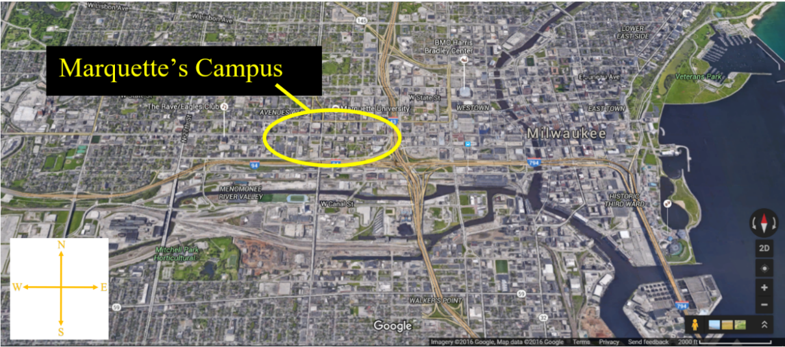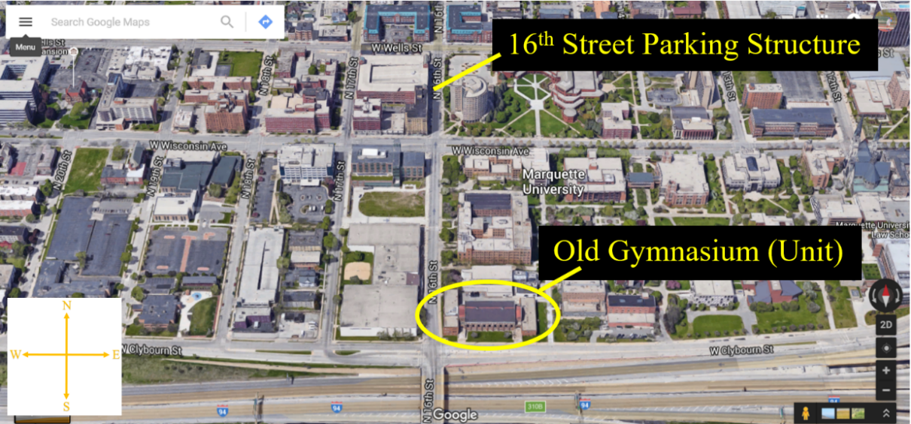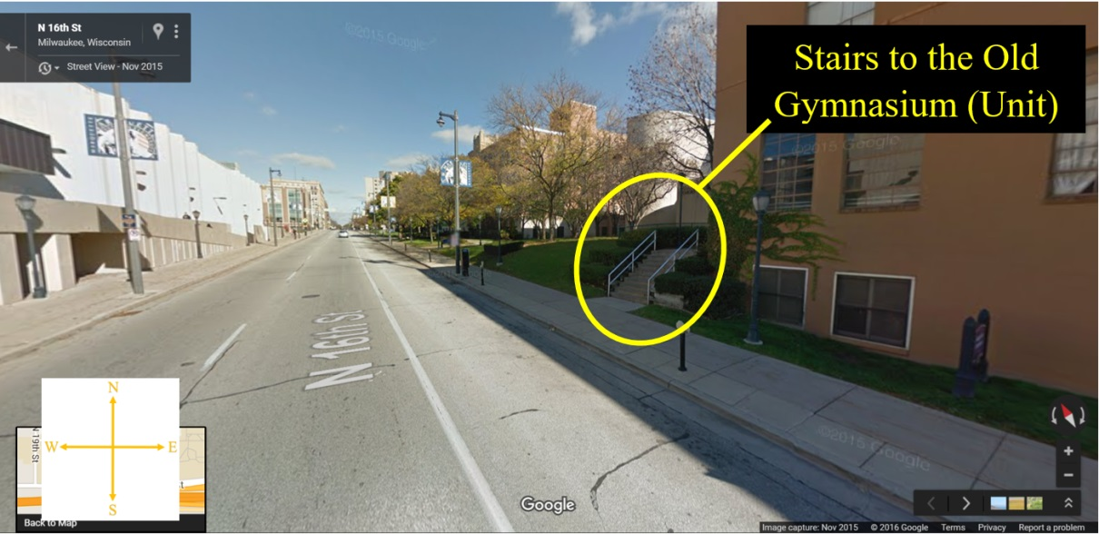**Getting to the Unit**

**Marquette Gymnasium, 1532 W Clybourn St, Milwaukee, WI 53233**