**Introduction**

Adolescent children who ate breakfast scored higher on the STROOP test than those who did not (Cooper Bandelow and Nevill, 2011)

Participants who rarely ate breakfast reported more depressive symptoms than those who frequently ate breakfast (Lee et al., 2017)

If an individual eats breakfast, then the individual’s cognitive performance will increase throughout the day.

If the individual consumes food for breakfast they will have a significantly higher mood compared to individuals who consume nothing at all for breakfast or who substitute eating breakfast with caffeine consumption.

**Method**

**Participants**

Undergraduate students (*N* = X)

Age 18-22 (*M* = X, *SD* =X)

X% Female

X% Males

Year in School

Ethnicity

**Survey Measures:**

Breakfast eating habits

Participant’s consumption routine

**Procedure:**

Administered informed consent

Sent twice daily surveys over the course of an academic week via email

Recorded responses from survey on participant’s mood and cognitive performance

Debrief

**Results**

Hypothesis one- paired samples t-test

alpha level = .05

indicated a significant increase in cognitive performance after the 12:30pm. Survey

M = X, SD = X

after 7:00 pm survey:

M = X, SD = X, t(X)=X, p< .05

Hypothesis two- one-way ANOVA indicated that the effect of breakfast was not significant F(X,X) = X, p> .05

Scheffe Post Hoc criterion for significance indicated low positive affect in participants who consumed food (M = X, SD = X), in those who consumed caffeine only (M = X, SD = X) and in those who did not consume anything (M = X, SD = X), F(X,X) = X, p> .05

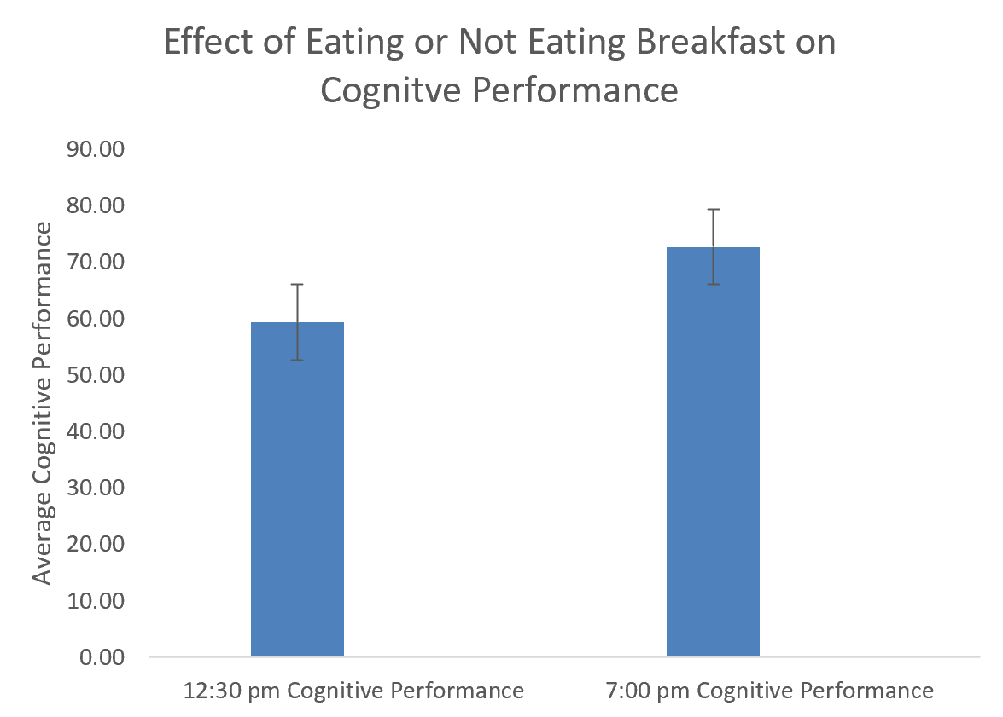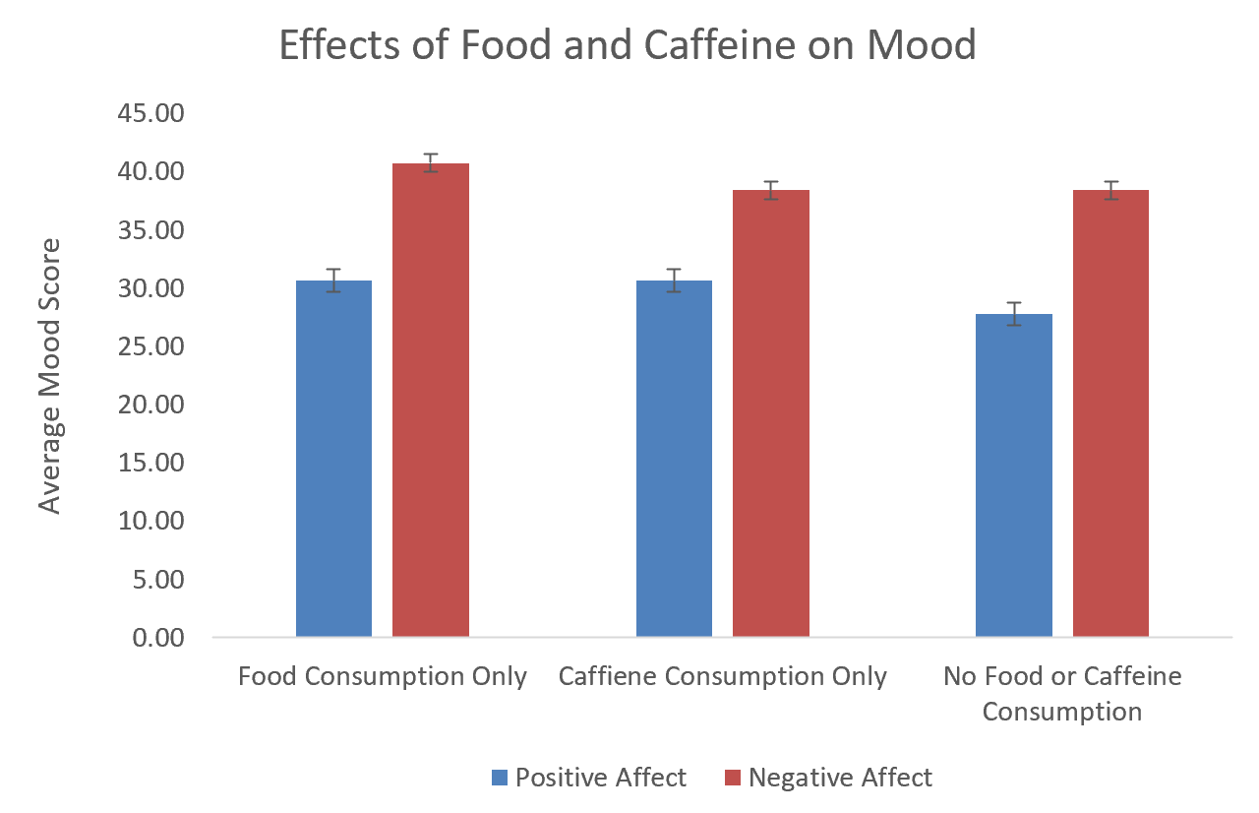

**Discussion**

Breakfast consumption has a significant impact on cognitive performance, but does not have a significant impact on mood

The results of hypothesis one are consistent with previous research as demonstrated by Defeyter and Russo (2013)

The results of hypothesis two are not consistent with the literature as demonstrated by Ferrer-Cascales et al. (2018)

**References**

Cooper, S. B., Bandelow, S., & Nevill, M. E. (2011). Breakfast consumption and cognitive function in adolescent schoolchildren. *Physiology & Behavior*, *103*(5), 431–439. doi: 10.1016/j.physbeh.2011.03.018

Defeyter, M.A., & Russo, R. (2013). The effect of breakfast cereal consumption on adolescents’ cognitive performance and mood. *Frontiers in Human Neuroscience, 7,* 789. Doi: 10.3389/fnhum.2013.00789

Ferrer-Cascales, R., Sánchez-SanSegundo, M., Ruiz-Robledillo, N., Albaladejo-Blazquez, N., Laguna-Perez, A., & Zaragoza-Marti, A. (2018). Eat or Skip Breakfast? The Important Role of Breakfast Quality for Health-Related Quality of Life, Stress and Depression in Spanish Adolescents. *International Journal of Environmental Research and Public Health, 15*(8), 1781. doi: 10.3390/ijerph15081781

Lee, S. A., Park, E.-C., Ju, Y. J., Lee, T. H., Han, E., & Kim, T. H. (2017). Breakfast consumption and depressive mood: A focus on socioeconomic status. *Appetite*, *114*, 313–319. doi: 10.1016/j.appet.2017.04.007