Research Security Training: Administrative Process

This process document is designed to address the Research Security Training (RST) requirement which can be found in many federal agency policies, including but not limited to Research Security Training | NSF - National Science Foundation (effective 11/10/25) and NOT-OD-26-017: Research Security Training Requirements for NIH (effective 5/25/26) (“Covered Sponsor”). These policies require PIs, Co-PIs, and other individuals identified as senior/key personnel to complete RST within the 12 months prior to proposal submission in addition to other time points (e.g., current and pending support, no cost extensions, etc.). All Marquette personnel must complete the training in Marquette’s D2L platform. If training is not completed by all required parties, the proposal will not be submitted.

WHAT: Research security training aims to raise awareness of risks and threats to the global research ecosystem, including undue foreign influence, cybersecurity threats, and compliance issues related to federal funding. It helps researchers understand how to protect sensitive information, manage international collaborations responsibly, and comply with federal regulations.

WHO: ALL individuals identified as senior/key personnel (Covered Individuals; CI) on an application to or award from a Covered Sponsor are required to take the training as prescribed by the Covered Sponsor. This includes Principal Investigators (PI), Co-Investigators and any other individual who meets this definition. In addition, CIs may be required to take RST as a part of Responsible and Ethical Conduct of Research (RECR) training.

WHEN: Identified CIs are required to take the training within 12 months prior to proposal submission or at a different time point as required by the Covered Sponsor. CIs may also be identified to take RST upon enrollment in the RECR program.

PROCESS:

Identification
Covered Individuals are identified as follows:

- Project Planning and Development (PPD) team or Grants Administration team identifies CIs when ORSP is notified that a PI would like to begin work on an application to a Covered Sponsor or when a CI needs to complete Current and Pending Support.
- PIs may notify the Project Planning and Development team or the Grants Administration team if they would like to take the training in advance of preparing an application to a Covered Sponsor.
- Post-award may identify a CI if a no cost extension requires RST.
- CIs (Senior/key personnel) may send an e-mail to ORSPppd@marquette.edu to request that they be enrolled in the RST tutorial.
- CIs may be required to take RST as a part of the RECR program; the Grants Assistant will perform enrollment and monitor completion.

Enrollment
The RST tutorial can be found at https://d2l.mu.edu/d2l/home. The PPD team is responsible for ensuring that all CIs are enrolled and have completed the training prior to a proposal submission. PPD or Grants Administration will ensure completion for CPS and Post-award will ensure completion prior to any no cost extension requiring RST. In the case of RECR, the Grants Assistant will ensure completion of any CIs in conjunction with the Faculty Fellow.

New CI Enrollment – Not in D2L System
Upon identification of a new individual who must take the RST tutorial, the ORSP team member doing the enrollment will complete a Person Training record in Kuali. This is done by selecting Common Tasks -> Person Training.

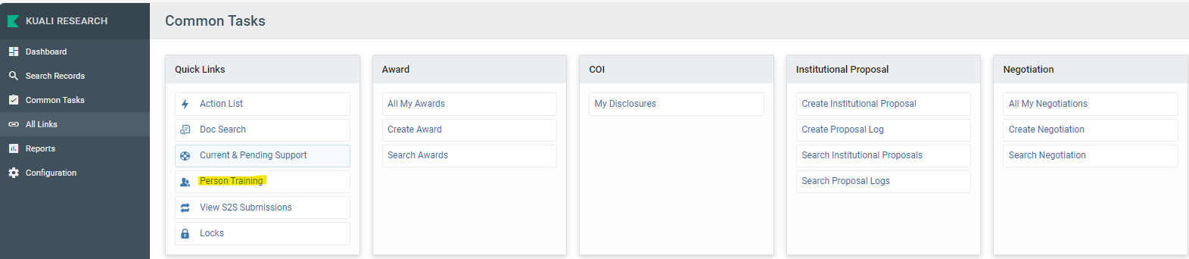

Click on the “create new” button in the upper right corner.
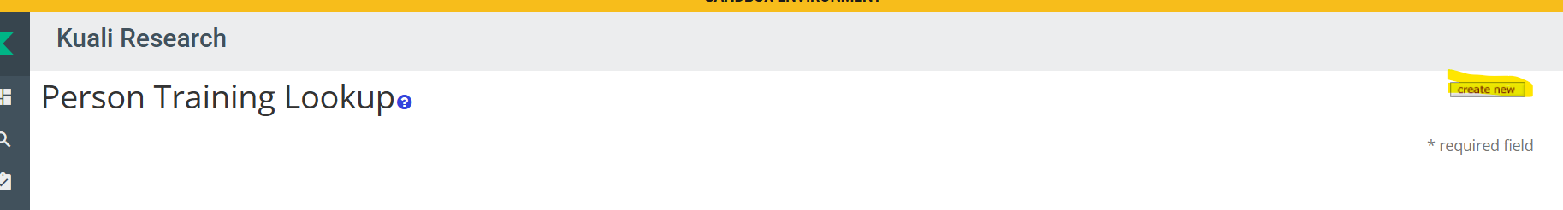

The following data elements are then entered:

Description = Add
Person ID = Covered Individual – must look up name so a numerical value is added for id
Training = Research Security Training
Date Requested = enter current date
Comments = enter ‘RST training is required’
Click Submit button at bottom of page

This will enroll the individual in the tutorial.



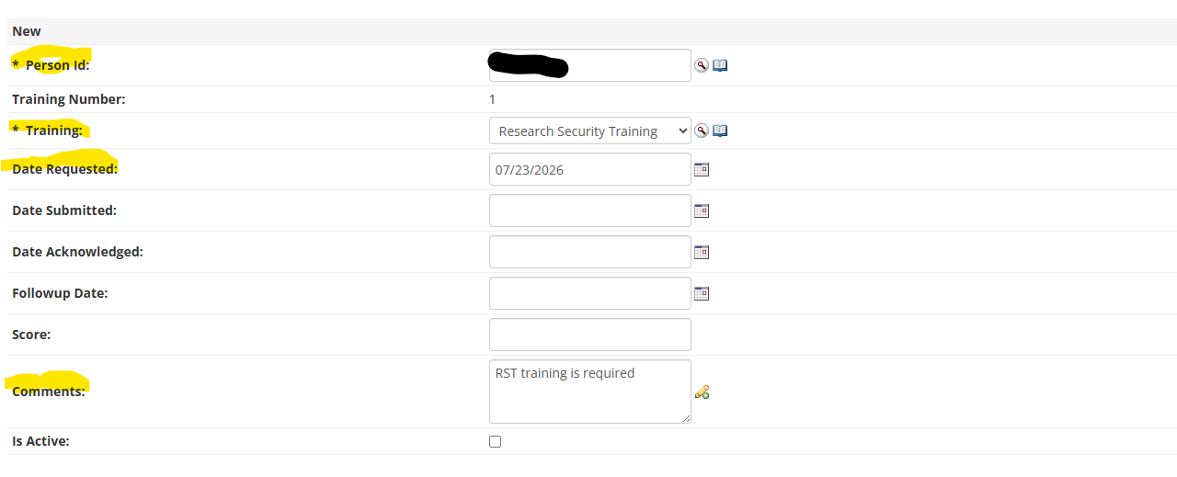

Renewal CI Enrollment
If an individual has already taken the RST tutorial, they will have continuous enrollment. When their training is close to expiring (30 days from the expiration date), the system will send the CI an e-mail letting them know that they will need to retake the tutorial. When a renewal is needed, the CI will be automatically enrolled in a Research Security Training –Refresher course. ORSP cannot directly enroll a CI in the RST-Refresher; the individual must complete the initial training. Upon completion of the initial training, the only course option a CI will see in D2L is the Refresher.

Once a CI is enrolled, they are enrolled until they complete the course. As an example, if a CI is enrolled in November, but decides not to submit an application at that time they are no longer required to complete RST. The CI should NOT be deleted or unenrolled but rather will remain enrolled and will have access to the course until the course is completed.

Any new CI will be enrolled in D2L and will receive a notification e-mail at 5:00 pm on the day they are enrolled. If they are enrolled after 5:00 pm, their enrollment will become active at 5:00 pm on the next business day. Once the enrollment process is complete, the CI will have access to the RST tutorial. CIs must complete the entire tutorial, which takes about an hour to complete (the Refresher will take approximately 30 minutes). The CI will see their completion immediately in D2L and will be able to print a certificate of completion. Certificates should be saved by the CI on their own device as a .pdf and kept on file in case they need it in the future (e.g., if they are a subrecipient on an NSF non-collaborative grant application). ORSP will not serve as a repository for CI certificates of completion. The RST completion date will be recorded in D2L immediately and it will appear in Kuali at 5:00 pm on the next business day.

Notifications
CIs who have taken the RST tutorial will receive a system-generated e-mail 30 days prior to the expiration date of their current training. The e-mail will note that they have 30 days until their current certification ends. The e-mail will also include the expiration date. A follow up e-mail will be sent at 5 days from the expiration date as necessary. ORSP will not take any standard additional reminder action. No notifications will be automatically sent after the five-day notification.

If a CI has previously taken the tutorial and no longer needs to retake it, they will still receive the reminders. New users will also receive a reminder if they do not take the training within 30 days of enrollment. They will need to successfully complete the tutorial prior to being able to submit their application or complete their award action.

Accessibility of Completion
All ORSP staff have access to the Person Training information in Kuali and can view all training records there, including follow-up dates. Note that Kuali will be updated after 5:00 pm on the next business day with any D2L activity after 5:00 pm on the prior day.

If a CI is enrolled at 5:00 pm and takes the training in the same 24-hour period, completion information may not appear in Kuali (but can be verified in D2L). A similar issue will occur if a CI retakes the training more than 30 days prior to their current expiration. An exception report will be generated in these cases, which is received by IT, Post-Award and the ORSP Executive Director; IT will work to resolve the issue.

Other
In rare instances, CIs who are not Marquette University employees may still need to take RST. If the CI is not employed by an entity that has an RST program in place, they will need to complete the training at Research Security Training | NSF - National Science Foundation and provide the certificate to the PPD team who will upload the certificate into Kuali prior to submission of the application. ALL MARQUETTE EMPLOYEES MUST TAKE THE RST IN D2L.

At the time of application, Marquette will accept a Letter of Intent from a potential subawardee’s authorized official as confirmation that personnel from that entity have completed RST. In cases such as an NIH RPPR where there might not be any direct confirmation from an authorized official and subawardee personnel do not have any updated Current and Pending Support to disclose, then ORSP will require those personnel to provide a copy of their most recent RST certificate. The certificate will not be shared with the sponsor, however it will be added to Kuali as confirmation that the requirement was met.

For audit purposes, no Person Training data will be deleted from D2L or from Kuali. There is no limit on enrollment and thus no purpose to delete.

The Executive Director of the Office of Research and Sponsored programs or their designee will review NSF guidance annually or more often as needed and work with IT Services to ensure the most recent version of training is available or address any changes in training required by new federal regulations.

Verifying RST Completion in D2L

From time to time, it may be necessary to view/verify RST training completion in D2L (e.g., if a proposal is due at 5:00 pm and the Covered Individual completed RST within the 24 hours prior). Please use the following guidance to determine whether a Covered Individual has completed the quiz.

Go to Homepage - Marquette University (Marquette D2L site) and log in. Only those with approved credentials will be able to see quiz results.

Click on Edit Course


Scroll down and click on Quizzes
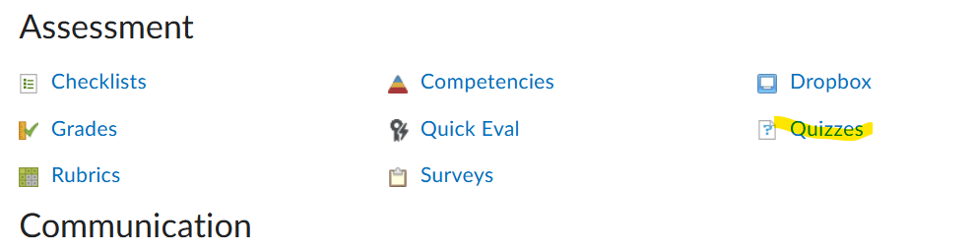

Click on the v next to Final Quiz, then select Grade from the drop-down menu

You should be able to see all students in alphabetical order by first name and the score on their quiz. You are also able to search by name. Since there is only one question, 100% should show in the grade column for all completers.

