Updated: JULY 10, 2026
ORSP Reports
Marquette University | Office of Research and Sponsored Programs

Table of Contents

Applications
Grant Applications 2
Individual Applications 3
First Time Applicants 4
Community Engaged Applications 5
Awards
Grant Awards 6
Top Ten Sponsors 7
Individual Awards 8
First Time Awardees 9
Community Engaged Awards 10
Post-award Management
Proposal Development Commitments 11
Upcoming Reports Due 12
Grant Budget Dashboard 13
Grant Budget History 14
Grant and Salary Detail 15
Grant Operating Encumbrances & Invoices on Hold 16
Grant Payroll 17
RECR 17
E-Verify 17
Exceptions Report 18

Grant Applications
Proposals to external sponsors that have been submitted through Marquette University

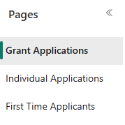

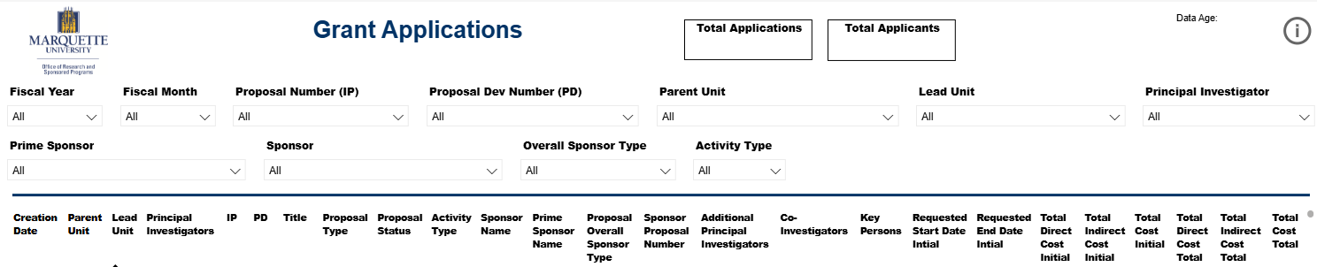

Individual Applicants
Proposals submitted by Marquette personnel to external sponsors and are received by the individuals directly, rather than through the university.

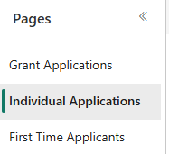

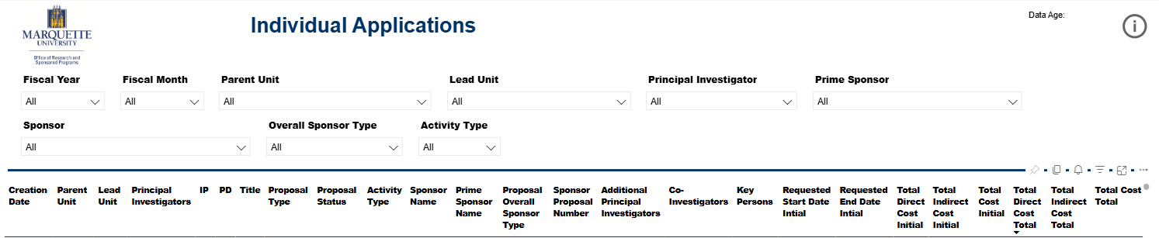

First Time Applicants
First time faculty, students and staff applicants who serve as Principal Investigators

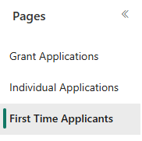

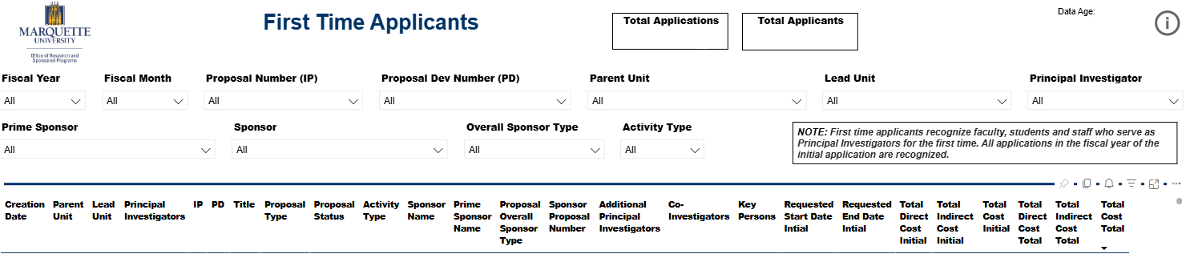

Community Engaged Applications
Proposals to external sponsors that include community partners.

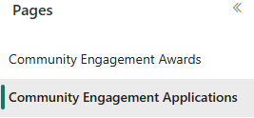

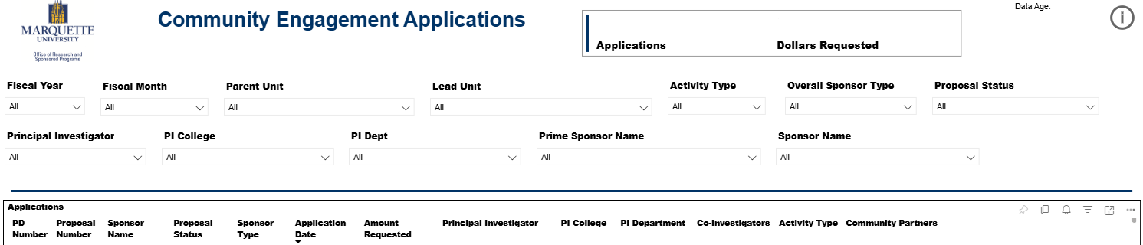

Grant Awards
Awards from external sponsors that have been legally obligated to Marquette University

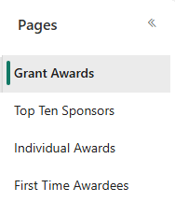

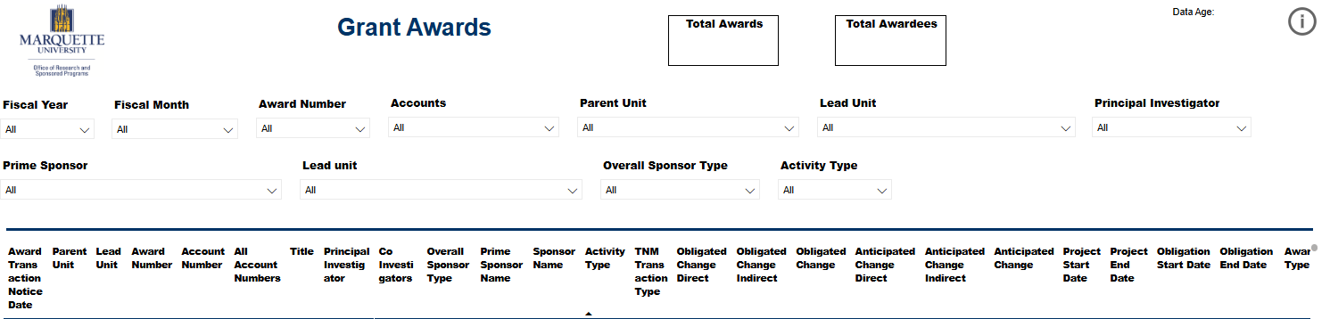

Top Ten Sponsors
High level information about Marquette’s largest sponsors within a selected time period.

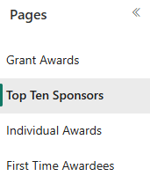

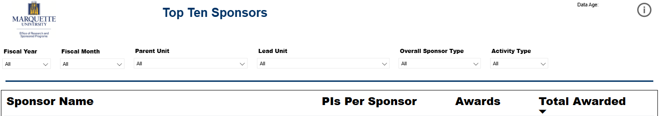

Individual Awards
Awards from external sponsors received by Marquette personnel directly, rather than through the university.



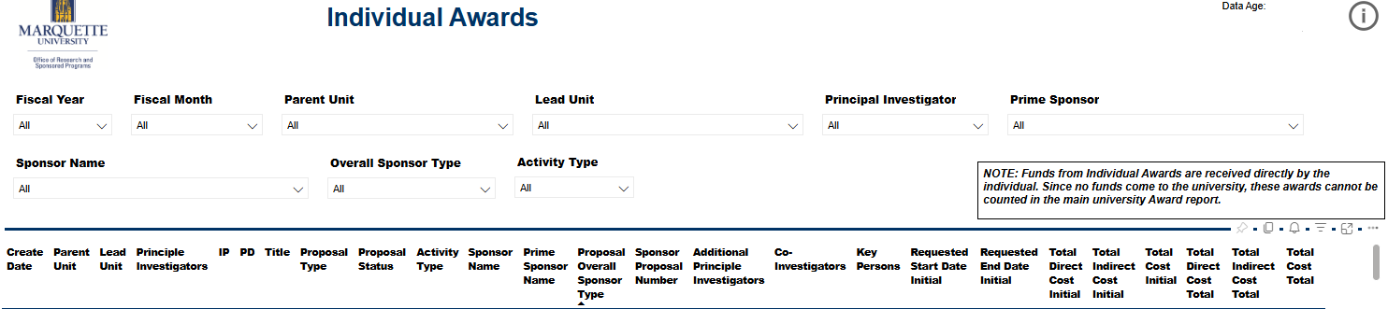

First Time Awardees
First time faculty, students and staff awardees who serve as Principal Investigators

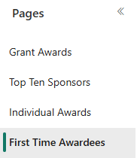

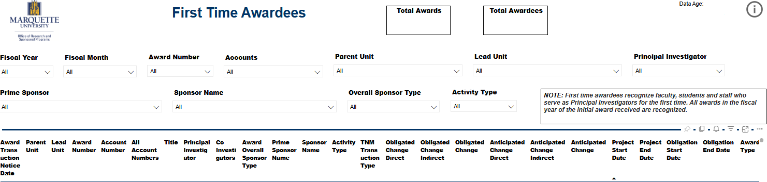

Community Engaged Awards
Awards are obligated by external sponsors that include community partners.

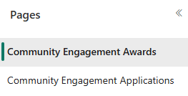

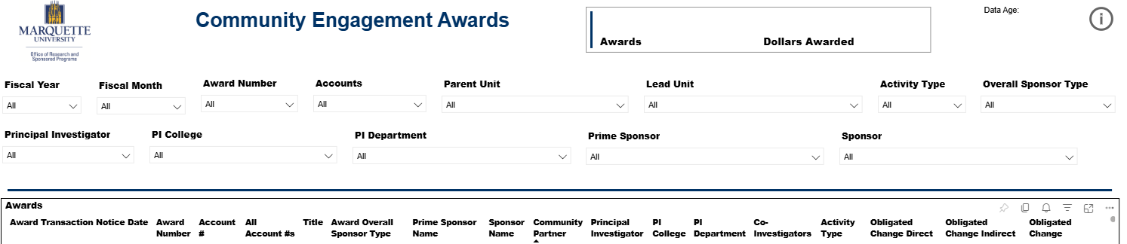

Proposal Development Commitments
Supplemental Information from proposals that outline commitments made including effort, course buyouts, tuition, space, cost sharing, etc.

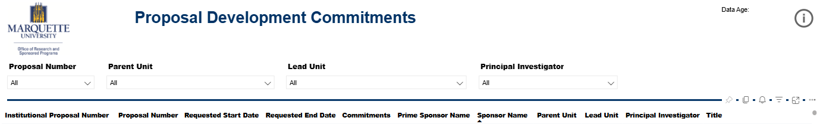

Upcoming Reports Due
List of upcoming reports due and due date

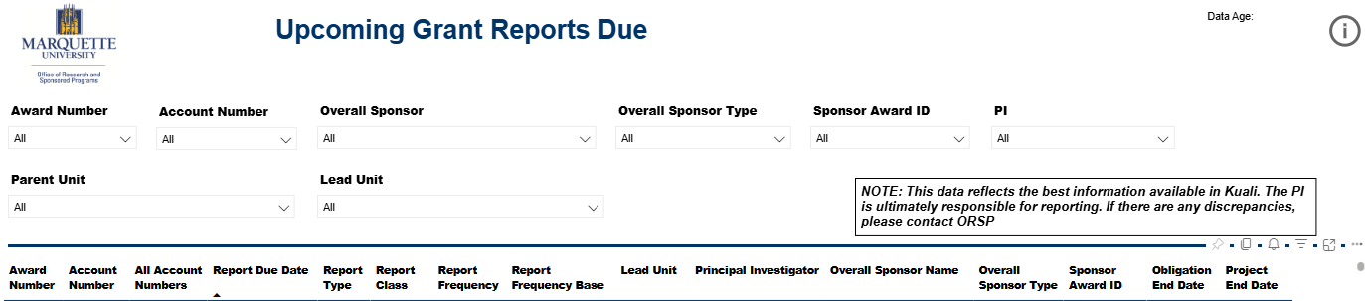

Grant Budget Dashboard
This dashboard represents a status overview for Grant accounts at the university.

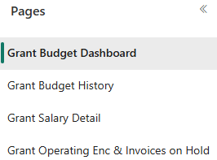

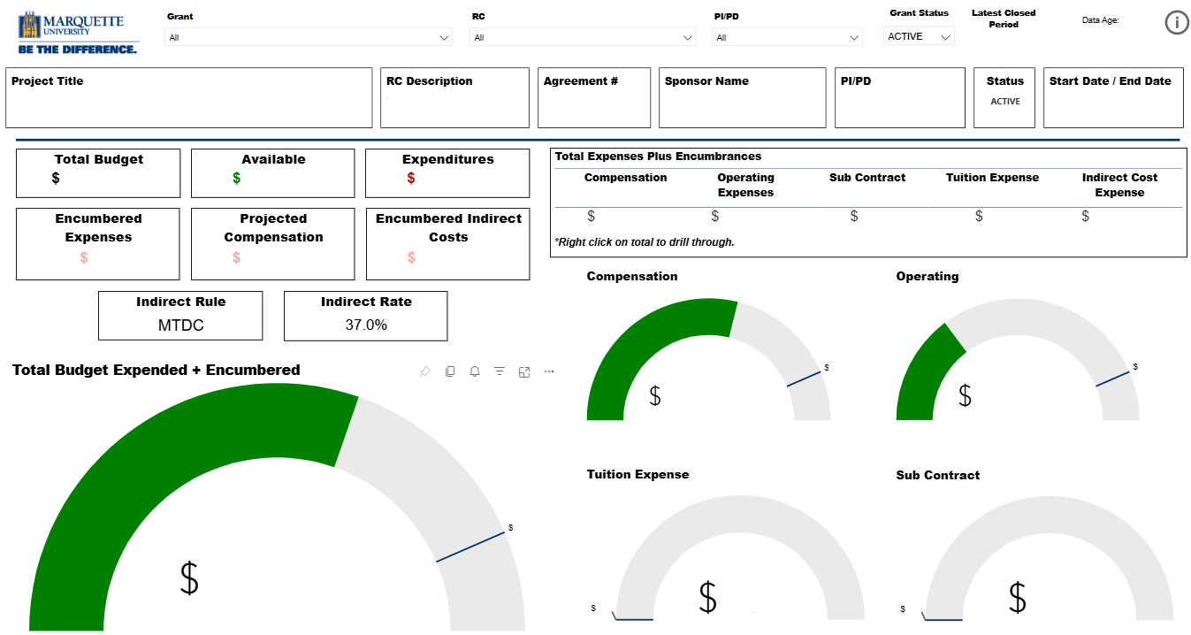

Grant Budget History
Itemized list and description of expenditures based on natural (entries posted daily, indirects posted at month-end)

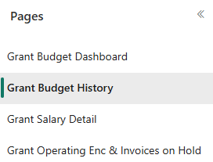

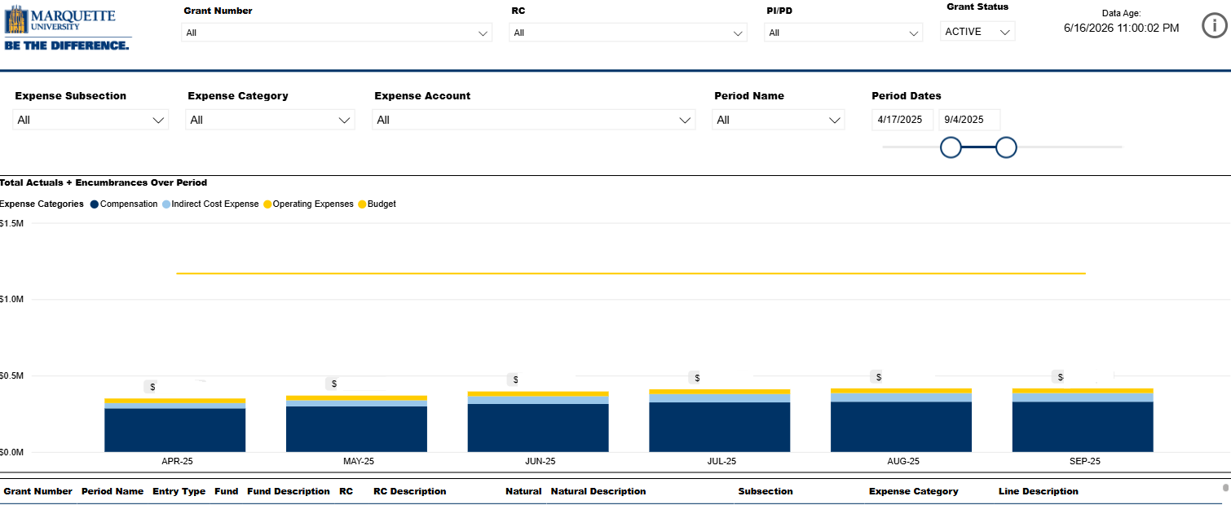

Grant Salary Detail
Sortable list of salary spent, pulled from labor distribution reports. This report is helpful in calculating effort reporting (entries posted with payroll close)

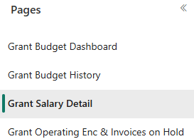

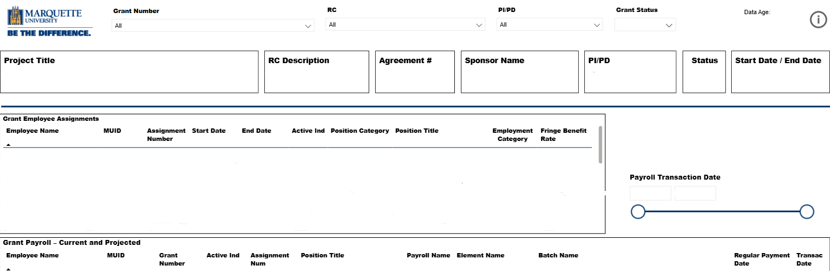

Grant Operating Encumbrances & Invoices on Hold
A list of items in which funds are currently encumbered and waiting to be paid. This tab provides details for: Open Purchase Orders (POs) that appear in encumbrance report; anything on hold within Accounts Payable (A/P) due to insufficient funds.

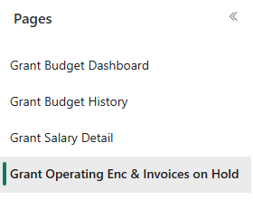

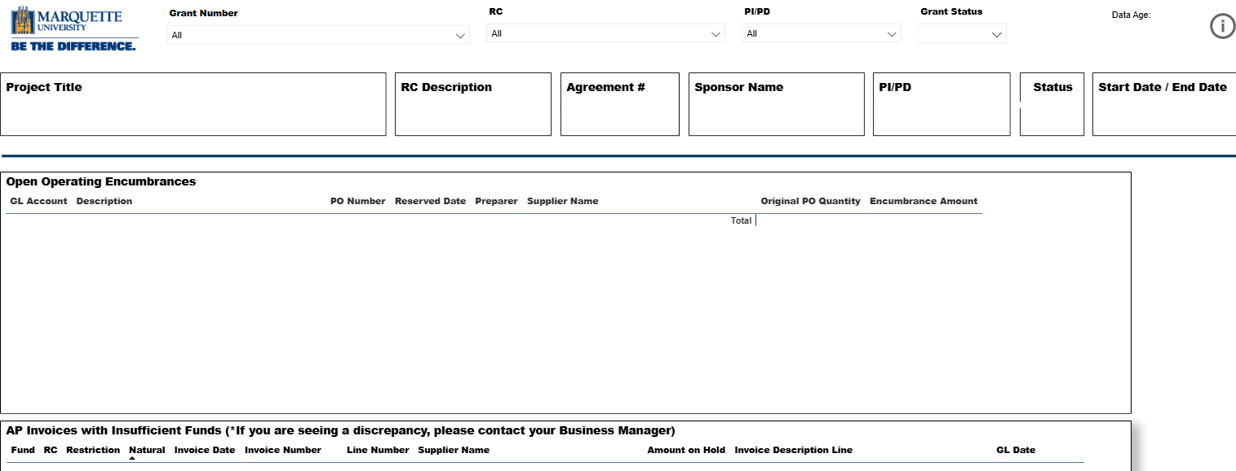

Grant Payroll
These reports compare labor distribution reports against specific award criteria to ensure all individuals paid through grants fulfill award requirements.

Grant Payroll – RECR
This report displays all employees paid under National Science Foundation and US Department of Agriculture grants, as well as other select awards that require completion of Responsible and Ethical Conduct of Research (RECR) training and is used to ensure that all individuals paid from these grants have fulfilled this requirement.

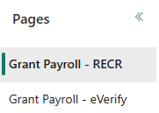
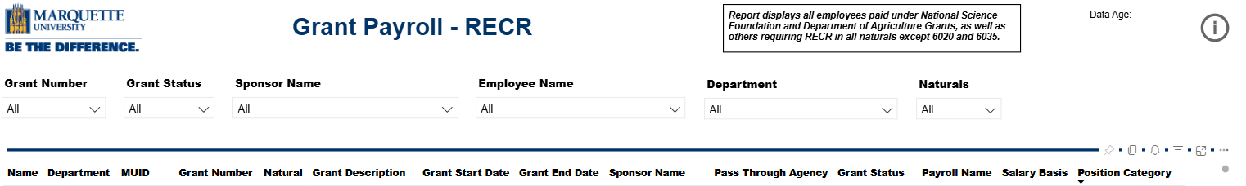

Grant Payroll – E-Verify
This report shows all employees paid under awards that contain E-Verify requirements and is used to ensure that all individuals paid from these grants have met this requirement.

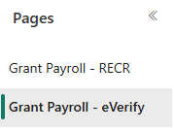
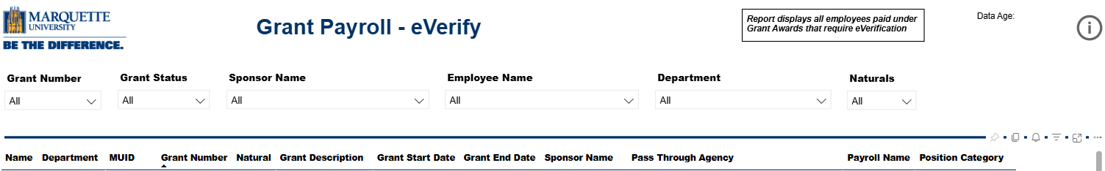

Exceptions Report
This report is used to identify and investigate discrepancies in grant financial data, including mismatches between total grant budget, authorized amounts, and project-to-date or ledger balances. It highlights potential issues—such as budget variances, negative balances, or misaligned totals.

