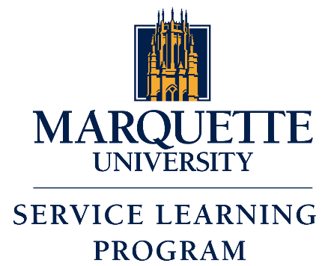
Course Planning Worksheet

Faculty Name: |  |  | Department:
Course Name and Number:
Service Learning Model To Be Used (Please select an option below):
☐ Placement | ☐ Presentation | ☐ Presentation Plus | ☐ Product | ☐ Project

- How many students will be in this class?

- Is this course a CORE class? If so, what category(ies)?

- Briefly describe the content of the course. What content areas or course themes might be enhanced through a community service experience?

- What are your specific learning objectives for service learners? (At the end of the course/service learning experience, students will…”)

- What kinds of community experiences will enhance learning in this course? (e.g. writing for an agency, community organizing, conversing with native Spanish-speakers, etc.)

- In what types of agencies would you like to have students placed? (If you have names of specific agencies, please list them.)

- (Optional Answer) Most Service Learning classes require Service Learning for all students. It is easier and more effective to have all students engaged in the same pedagogy. But sometimes it does make sense to offer service learning as an option. If you plan to make service learning optional, how will you design assignments to make sure there is a perceived balance (in time and effort) between service learning and traditional learning? (You should start with 20-30 hours on the service learning side to account for travel and service time.)

Service Learner Assignment | % of class | Traditional Learner Assignment | % of class

- What academic questions will you have your students consider while they are in the community?

- How will you integrate service learning into the class (discussions, work into lecture material, ask SL students to illustrate points being made, etc.)?

- What demonstration of learning will you have service learners produce (journals, paper, oral report, etc.)?

- What is your plan to evaluate the learning for the service learners? (% of total grade; what will the grade be based on, etc.)

- Do you have a plan for assessing the learning that occurred through service learning? If so, please describe.

- In what way(s) will you directly interact with our community partners through this course?

- What more do you need to know, or what help do you need from the Service Learning Program in order to design a service learning component in this course?

Please return to the Service Learning Program Director, Kim Jensen Bohat at kimberly.jensen@mu.edu and a meeting can be scheduled to discuss the course.

