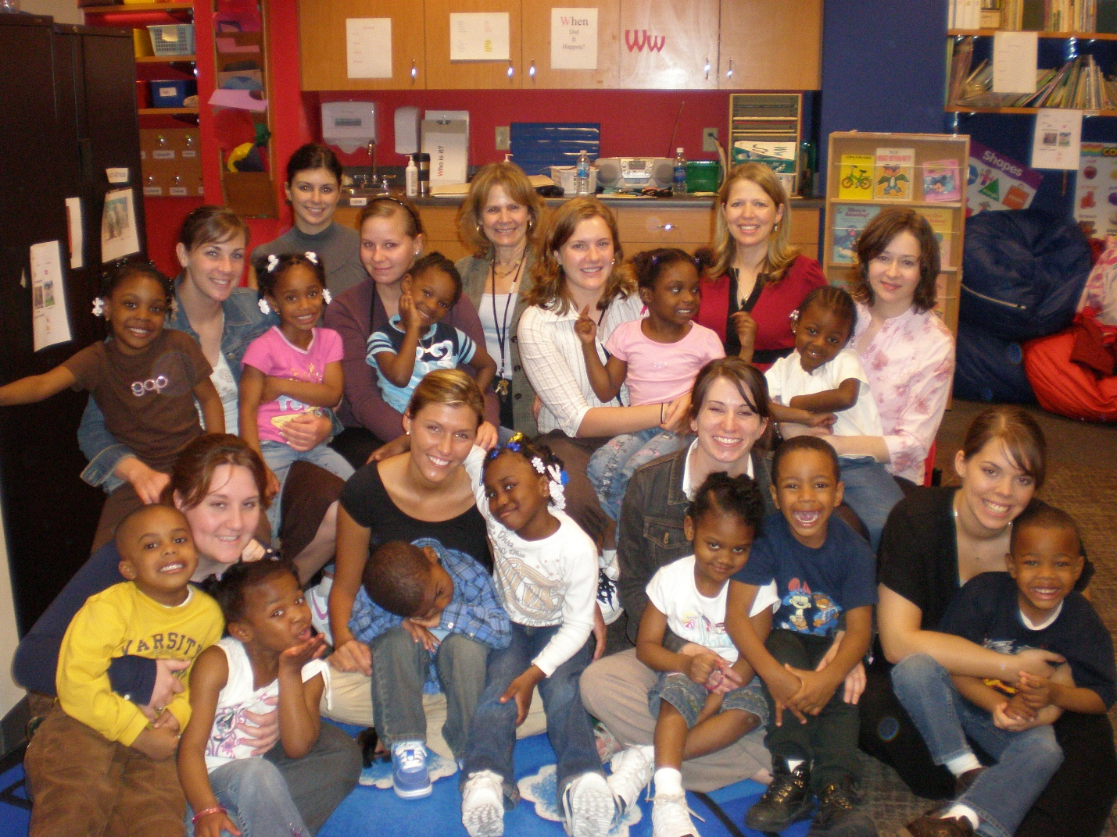

child language and literacy (cll) LAB
Our areas of research interest include:
- Developing and testing language and literacy assessments that are culturally and linguistically sensitive and appropriate for children who speak nonmainstream English dialects.
- Investigating innovative methods of using language sample analysis for assessment of language abilities.
- Investigating the efficacy of professional development in language and literacy for early childhood educators.

Current Projects
- The use of sentence imitation to measure dialect density.
- Using sentence diversity from narrative language samples to assess linguistic development.
- The utility of a simplified narrative scoring tool to assess children’s language development.

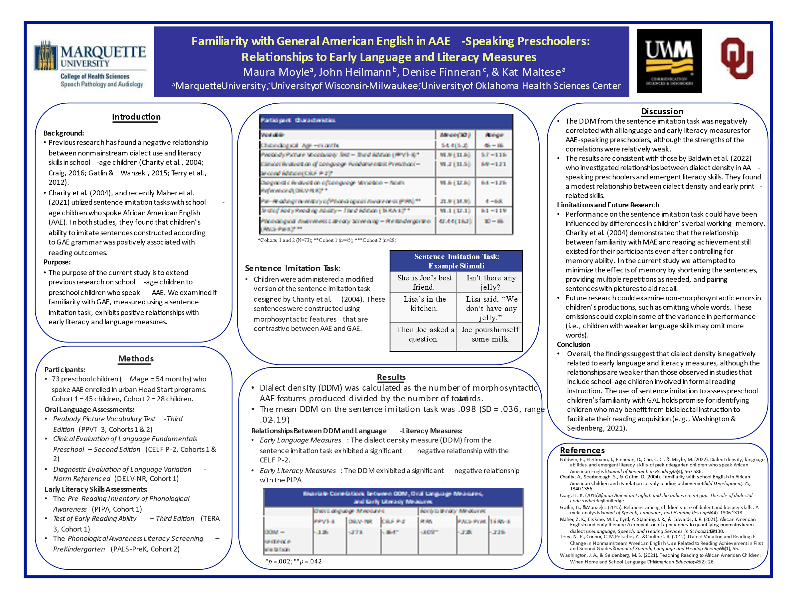

Interested in Collaboration?
Collaborators are particularly sought across the educational, reading, literacy and linguistic disciplines. However, any collaborations that align with our research interest would be welcomed. Interested in collaborating with the CLL Lab please contact Dr. Maura Moyle (maura.moyle@marquette.edu).

How are students involved and can I get involved?
Graduate and undergraduate students are welcome in the CLL lab. Students have the opportunity to contribute to all stages of research. If interested in working or volunteering with the lab, or would like to complete a thesis, please email Dr. Moyle at maura.moyle@marquette.edu.

