







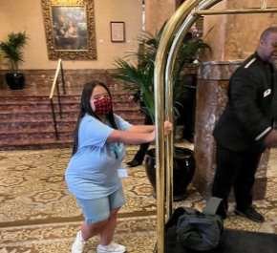
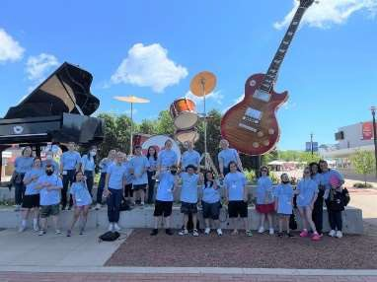
TIMs Camp 2025
(The Independence Movement)

Camp Session (Summer, 2025): Location:
June 9-June12 Marquette University Speech & Hearing Clinic
June 16-June 19 Barker Cramer Hall
June 23-June 26 604 N. 16th Street
Milwaukee, WI 53223

Days: Monday to Thursday
Time: 9:00 am-12:00 pm
Session Fee: $300.00 ($25 Due at registration)

Priority Registration deadline: March 1, 2025

Who: Tim’s Camp will support adolescents and young adults (ages 11 through 21+) with special needs as they move toward independence through vocational and social accomplishments. The camp will provide specialized speech- language therapy to promote functional communication and related skills as well as opportunities to apply them in real- life settings. Camp will run for three weeks, four times a week, for three hours each day (9:00-12:00). Each week two of the sessions will be comprised of individual/small group speech and language therapy, group instruction, guided practice of skills and home practice activities. Two additional sessions per week will be comprised of brief individual/small group speech and language therapy, group review of targeted skills and group outings.
Please email speechandhearingclinic@marquette.edu or call 414.288.7426 to register!

